**Documentation of Experiments – June 13th 2019**

Two county bridges located in Lincoln and Ashland were tested on June 13th, 2019. The tests were performed via loading the bridges using a Type 3 truck provided by the Nebraska Department of Transportation. This document aims at providing a description of the truck load, details of the sensor network, loading trajectories, and the recorded data files associated with each scenario. The recorded files for each bridge are separately placed in folders labeled according to the speed of the truck. In each folder the converted Microsoft Excel and MATLAB files are accompanied.

**Truck Description**

Truck Type 3 Nebraska Legal Truck (Sterling) was used for conducting the bridge loading. The axle’s loads were respectively 16320 lb. and 33000 lb. for steer and tandem wheels.

**Sensor Network**

Details of sensor networks related to each bridges are documented in files named “C00551235502_Lincoln_SteelComposite.pdf” and “C007800491001_Ashland_Concrete.pdf”.

**C007804910 – Concrete Bridge in Ashland**

Tests were performed at 5, 15, 30, and 45 mph. A dense array of train data was recorded while the truck traveled over the bridge. Additionally, two uniaxial accelerometers were installed on the exterior eastern bridge plank. For each loading scenario, recording was started a few seconds before the truck reached the bridge and it was stopped once the truck was completely off of the bridge. Tables 1-4 link the recorded *.tdms files to each loading scenario. Figure 1 shows the trajectories of truck loading scenarios.

Table 1: Concrete Bridge – 5mph Tests

|  |  |  |  |
| --- | --- | --- | --- |
| Test Run | TDMS file name | Direction Traveled | Lane Traveled |
| 1 | Bridge Test_R26_06_14_2019_12_47_15 | North | East |
| 2 | Bridge Test_R27_06_14_2019_12_48_38 | North | middle |
| 3 | Bridge Test_R28_06_14_2019_12_51_34_SemiTruck | North | middle |
| 4 | Bridge Test_R29_06_14_2019_12_52_19 | North | West |
| 5* | Bridge Test_R30_06_14_2019_12_53_40 | North | West |
| 6 | Bridge Test_R31_06_14_2019_12_54_31 | North | middle |
| 7 | Bridge Test_R32_06_14_2019_12_55_28 | North | East |
| 8 | Bridge Test_R33_06_14_2019_12_56_32 | North | East |
| 9 | Bridge Test_R34_06_14_2019_12_57_30 | North | middle |
| 10 | Bridge Test_R35_06_14_2019_12_58_22 | North | West |

*most data do not start & end on zero

Table 2: Concrete Bridge – 15mph Tests

|  |  |  |  |
| --- | --- | --- | --- |
| Test Run | TDMS file name | Direction Traveled | Lane Traveled |
| 1** | Bridge Test_R36_06_14_2019_13_02_17_BadTestDonotuse | North | East |
| 2* | Bridge Test_R37_06_14_2019_13_05_04 | North | East |
| 3* | Bridge Test_R38_06_14_2019_13_06_20 | North | middle |
| 4* | Bridge Test_R39_06_14_2019_13_08_09 | North | middle |
| 5 | Bridge Test_R40_06_14_2019_13_10_09 | North | West |
| 6 | Bridge Test_R41_06_14_2019_13_11_58 | North | West |
| 7 | Bridge Test_R42_06_14_2019_13_13_00 | North | West |
| 8 | Bridge Test_R43_06_14_2019_13_14_17 | North | middle |
| 9 | Bridge Test_R44_06_14_2019_13_15_31 | North | middle |
| 10 | Bridge Test_R45_06_14_2019_13_16_52 | North | East |
| 11 | Bridge Test_R46_06_14_2019_13_18_33 | North | East |

*most data do not start & end on zero **bad data

Table 3: Concrete Bridge – 30mph Tests

|  |  |  |  |
| --- | --- | --- | --- |
| Test Run | TDMS file name | Direction Traveled | Lane Traveled |
| 1 | Bridge Test_R47_06_14_2019_13_20_58 | North | middle |
| 2 | Bridge Test_R48_06_14_2019_13_22_45 | North | middle |
| 3 | Bridge Test_R49_06_14_2019_13_24_26 | North | middle |

Table 4: Concrete Bridge – 45mph Tests

|  |  |  |  |
| --- | --- | --- | --- |
| Test Run | TDMS file name | Direction Traveled | Lane Traveled |
| 1 | Bridge Test_R50_06_14_2019_13_27_31 | North | middle |
| 2 | Bridge Test_R51_06_14_2019_13_31_08 | North | middle |
| 3 | Bridge Test_R52_06_14_2019_13_34_31 | North | middle |

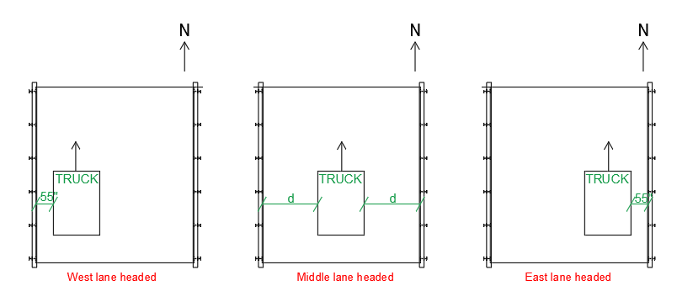

**Figure 1:** Showing the lanes travelled by the truck on the Concrete Bridge

**C005512355 – Steel Bridge in Lincoln North 14th Street**

Tests were performed at 5, 25, and 50 miles per hour. A dense array of strain data and a sparse array of acceleration data were recorded for each loading sequence. Table 5-7 respectively link the *.tdms files to the loading sequences at 5, 25, and 50 mhp. Figure 2 shows the trajectories of truck loading scenarios.

Table 5: Steel Bridge – 5mph Tests

|  |  |  |  |
| --- | --- | --- | --- |
| Test Run | TDMS file name | Direction Traveled | Lane Traveled |
| 1 | SteelBridgeLincoln_R14_06_14_2019_16_53_04 | North | East |
| 2 | SteelBridgeLincoln_R15_06_14_2019_16_56_11 | South | West |
| 3 | SteelBridgeLincoln_R16_06_14_2019_16_59_33 | North | East |
| 4 | SteelBridgeLincoln_R17_06_14_2019_17_01_13 | South | West |
| 5 | SteelBridgeLincoln_R18_06_14_2019_17_04_20 | North | East |
| 6 | SteelBridgeLincoln_R19_06_14_2019_17_05_48 | South | West |

Table 6: Steel Bridge – 25mph Tests

|  |  |  |  |
| --- | --- | --- | --- |
| Test Run | TDMS file name | Direction Traveled | Lane Traveled |
| 1 | SteelBridgeLincoln_R20_06_14_2019_17_10_20 | North | East |
| 2 | SteelBridgeLincoln_R21_06_14_2019_17_11_54 | South | West |
| 3* | SteelBridgeLincoln_R22_06_14_2019_17_14_45 | North | East |
| 4 | SteelBridgeLincoln_R23_06_14_2019_17_15_51 | South | West |
| 5 | SteelBridgeLincoln_R24_06_14_2019_17_18_14 | North | East |
| 6 | SteelBridgeLincoln_R25_06_14_2019_17_19_46 | South | West |

*most data do not start & end on zero

Table 7: Steel Bridge – 50mph Tests

|  |  |  |  |
| --- | --- | --- | --- |
| Test Run | TDMS file name | Direction Traveled | Lane Traveled |
| 1 | SteelBridgeLincoln_R26_06_14_2019_17_23_15 | North | East |
| 2 | SteelBridgeLincoln_R27_06_14_2019_17_25_38 | South | West |
| 3 | SteelBridgeLincoln_R28_06_14_2019_17_27_43 | North | East |
| 4 | SteelBridgeLincoln_R29_06_14_2019_17_30_11 | South | West |
| 5 | SteelBridgeLincoln_R30_06_14_2019_17_32_28 | North | East |
| 6 | SteelBridgeLincoln_R31_06_14_2019_17_34_38 | South | West |
| 7 | SteelBridgeLincoln_R32_06_14_2019_17_36_57 | North | Middle |

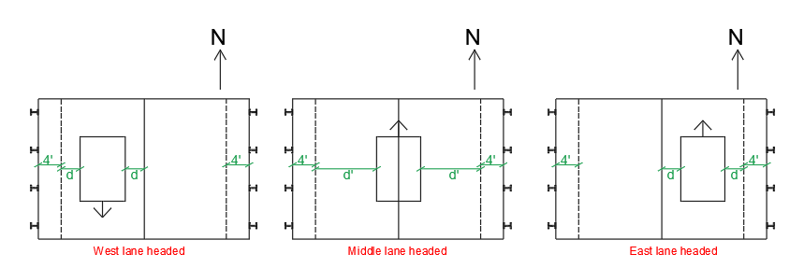

**Figure 2:** Showing the lanes travelled by the truck on the Steel Bridge